**Web Application 3 - Semantical HTML and Layouts**

**Purpose**  
In this activity, you will create two-column page layout for the Alps web site. Also, you will apply more CSS properties. You will be provided with the two HTML pages, index.html and tourism.html, in addition to styles.css where some of the styles are already added to the pages.

**Instructions**

1. Download the resources provided to you and add them to a newly created folder as you have done in previous activities.
2. Modify the navigation element in both pages, index.html and tourism.html, so that it contains an unordered list of hyperlinks.
3. Modify the html code of the two pages: index.html and tourism.html to have the following layout, by adding the needed semantical elements (header, main, footer) and division(s) if needed.

header

nav

main

footer

wrapper

1. Add the needed styles to create and format the two-column layout as shown.
2. Format the navigational list as shown below (refer to the provided solution captures). When the mouse is hovering over any link, the background color and the font color will switch (that is: background-color will become purple and the font color will become blue).

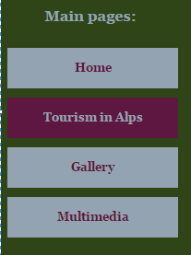

An **External** style sheet containing some of the main styles is already provided within the web site. Your work is to add the missing needed styles to format your pages as shown in the pdf solution files.

The colors used in the page are as shown:

|  |  |
| --- | --- |
|  | **#** **94A3B1** |
|  | **#** **2F4517** |
|  | **#** **5E1740** |
|  | **#** **DBDCD4** |

**Some guidelines:**

* The width of the wrapper is 90% and it is centered within the body.
* The width of the navigation division is 180px.

Refer to the ***IndexSolution*** and ***TourismSolution*** files and apply all the needed steps to have the same page